Mede Medical Center

User Manual

*Important Note:*

*Please do the following settings in case of Internet Explorer.*

*Go to Settings -> Compatibility View Settings*

*Uncheck Display Intranet sites in Compatibility View*

*Uncheck Use Microsoft compatibility lists*

*Close and Refresh Page*

**Purpose of the document:**

*Intention of this document is to guide the user to effectively use the application. The logical*

*Arrangement of the information and screen prints shall enable the user to understand the*

*Sequence and navigation of the system.*

1. *Connecting to the application :*

*You must connect to the application using the following address:*

*http://ctsc00849530701:9000/MedexMedicalCenter/*



*Fig 1*

1. *Authentication :*

*User can login as MedexAdmin, Doctor or Patient. Refer screen print below for the Patient login.*

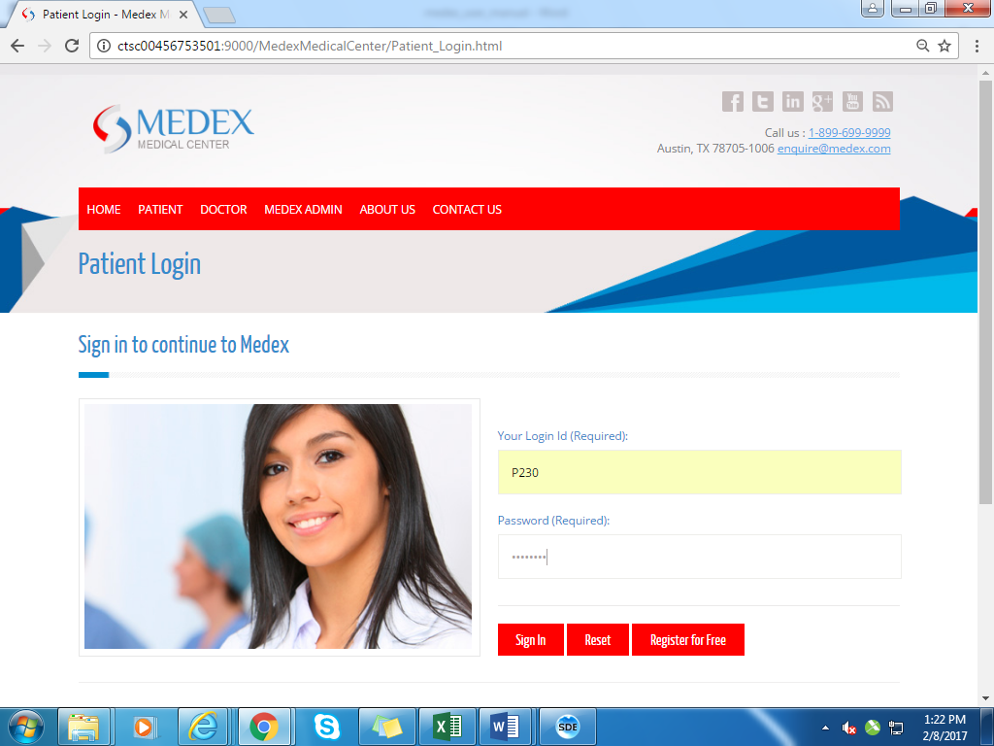

*Fig 2*

### 

### Sample Data:

|  |  |  |
| --- | --- | --- |
| User | Login Id | Password |
| Admin | A001 | Pass1234 |
| Doctor | D001 | Pass1234 |
| Doctor | D004 | Pass1234 |
| Patient | P230 | Pass1234 |

*User has to fill in all the mandatory field, not adhering to which lead to error message dialog to pop up. User can cancel the pop up by clicking* ***ok*** *in the dialog box and fill in the required field. Refer fig 3 when user leaves password field blank, error dialog pops up.*

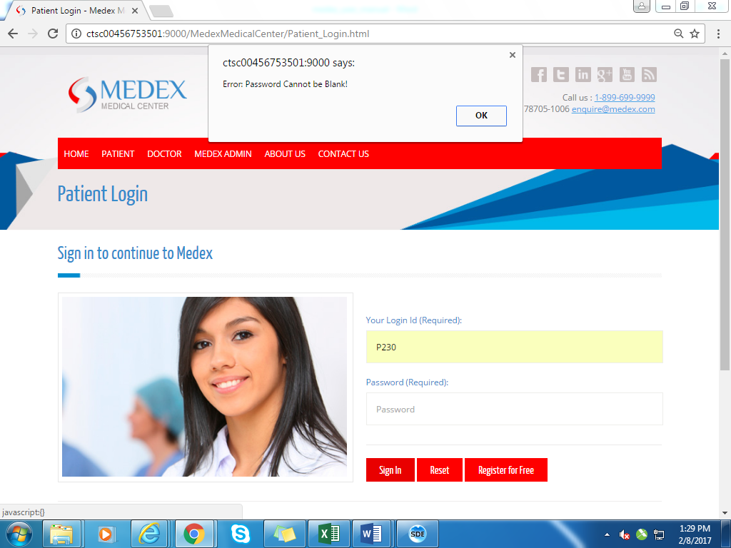

*Fig 3*

1. *Patient Module:*

*Once user logs in as patient he/she will be redirected to patient home page wherein he can book appointment, view appointments, cancel appointment as in fig 4* 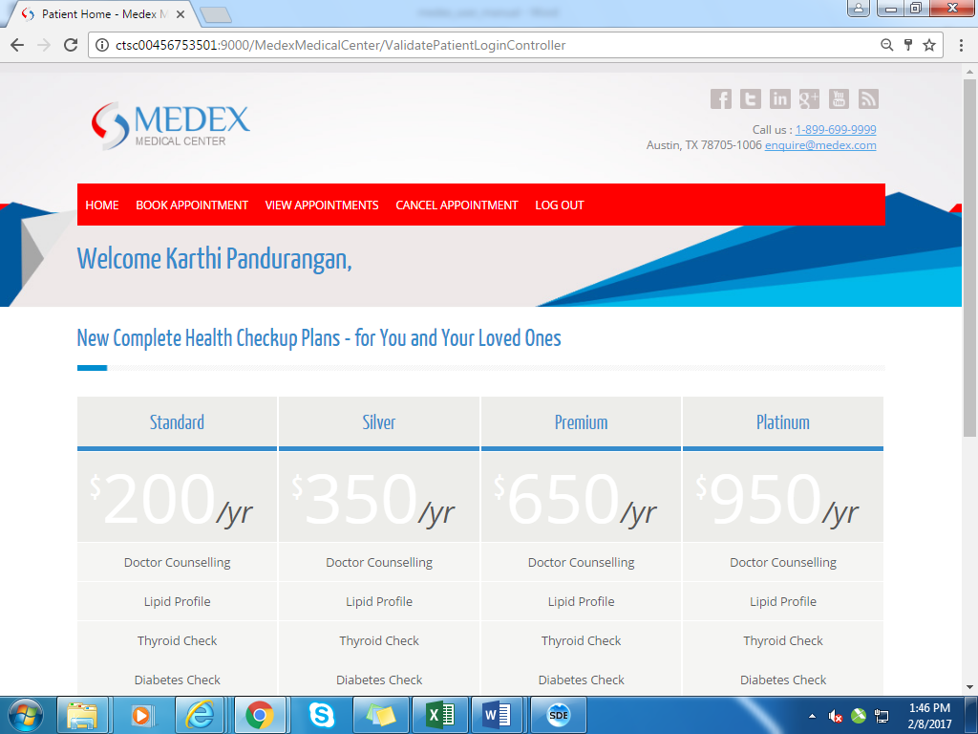

*Fig 4*

* 1. *Book Appointment:   
     If patient clicks book appointment link he will be able to book appointment with doctor. fig 5*

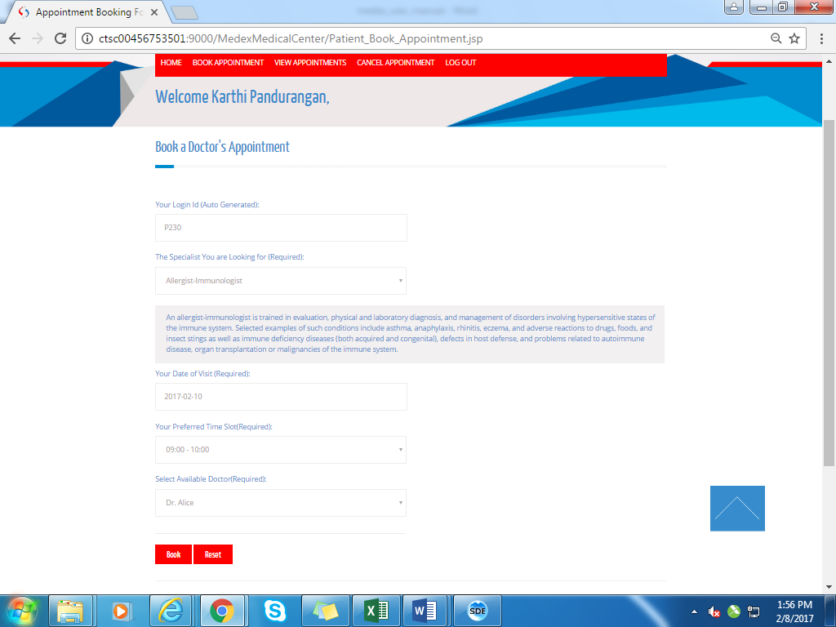

*Fig 5*

### Sample Data:

|  |  |  |  |
| --- | --- | --- | --- |
| Specialist | Your date of visit | Your preferred time | Select available doctor |
| Allergist-Immunologist | 2017/02/10 | 09:00-10:00 | Dr.Alice |

* 1. *View Appointments :*

*If patient hovers over view appointments link, he/she will be getting drop down to*

*Search by date and cancelled appointment page fig 6. He can select search by date*

*From the drop down fig 7.*

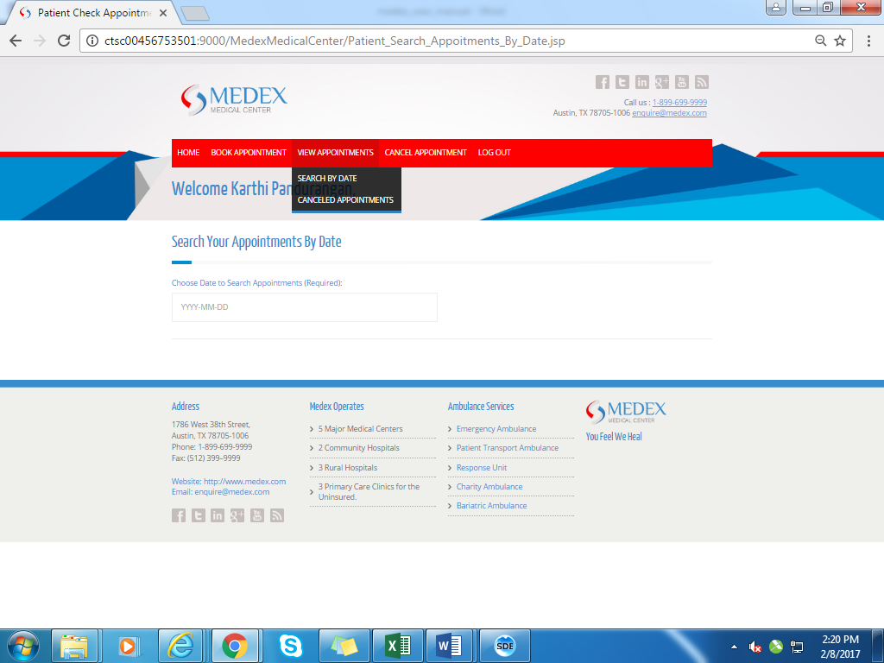

*Fig 6*

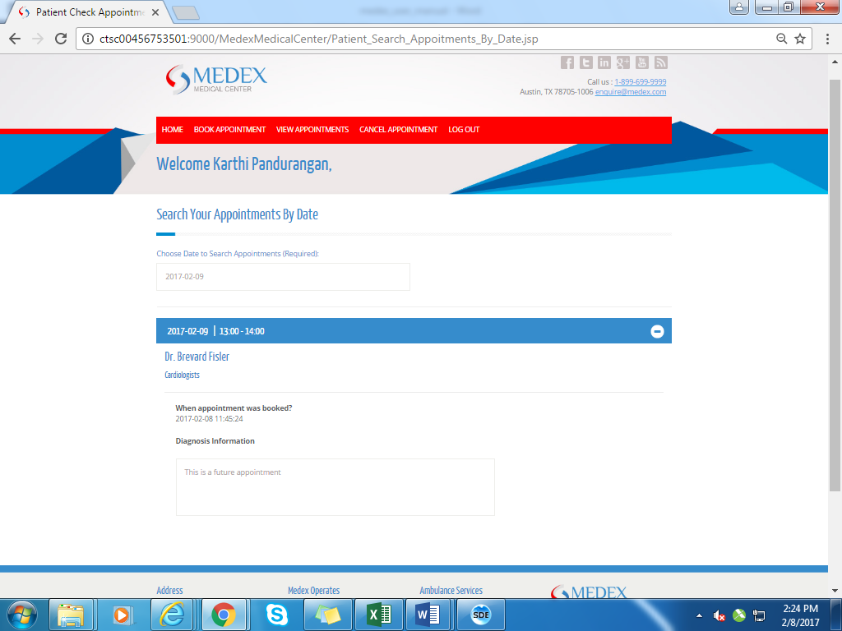

*Fig 7*

* 1. *Cancel Appointments:*

*If patient clicks cancel appointments he will be redirected to cancel appointment*

*Page fig 8. He/she can select appointment date from the drop down and cancel it.*

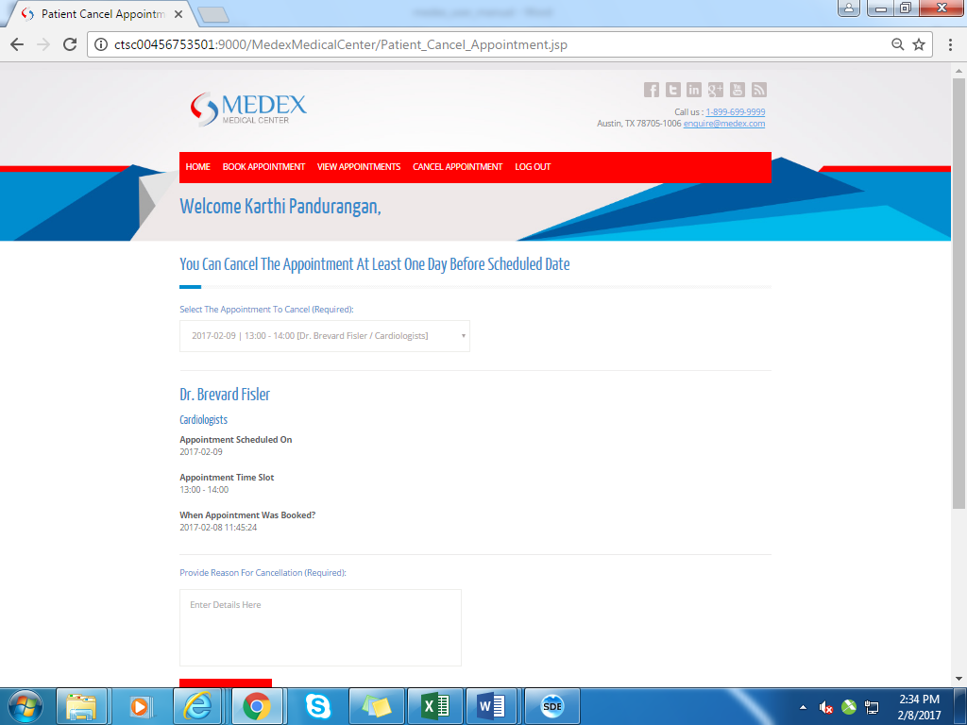

*Fig 8*

1. *Doctor Module: Once user logs in as doctor he/she will be redirected to doctor home*

*Page wherein he can book appointment, view appointments, cancel appointment as*

*In fig 9*

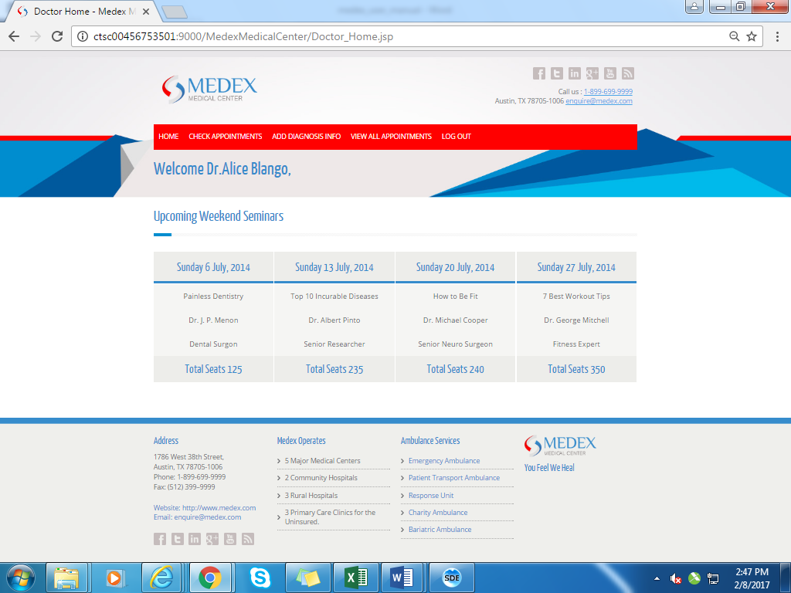

*Fig 9*

* 1. *Check Appointments:*

*Doctor can check appointment by clicking check appointment link fig 10*

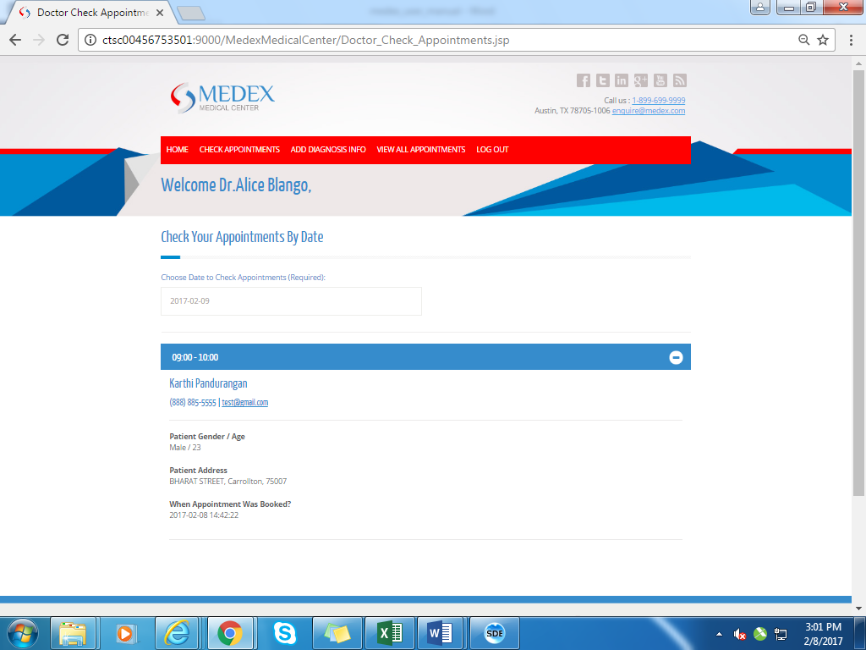

*Fig 10*

* 1. *Add Diagnosis:*

*Doctor can add diagnosis details by clicking add diagnosis info fig 11.He can*

*Select appointment date, time, and patient and add diagnosis details.*

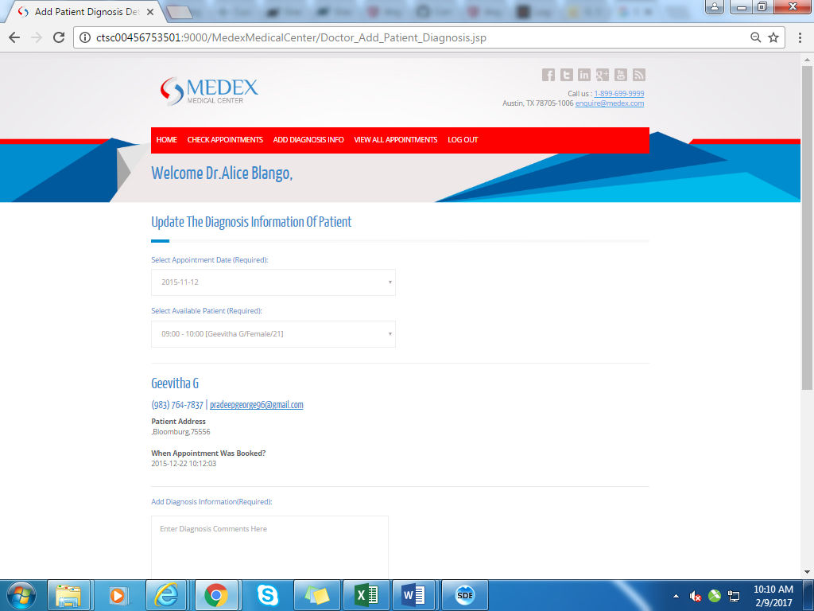

*Fig 11*

* 1. *View All Appointments:*

*Doctor can check all the appointments by clicking view all appointments fig 12.*

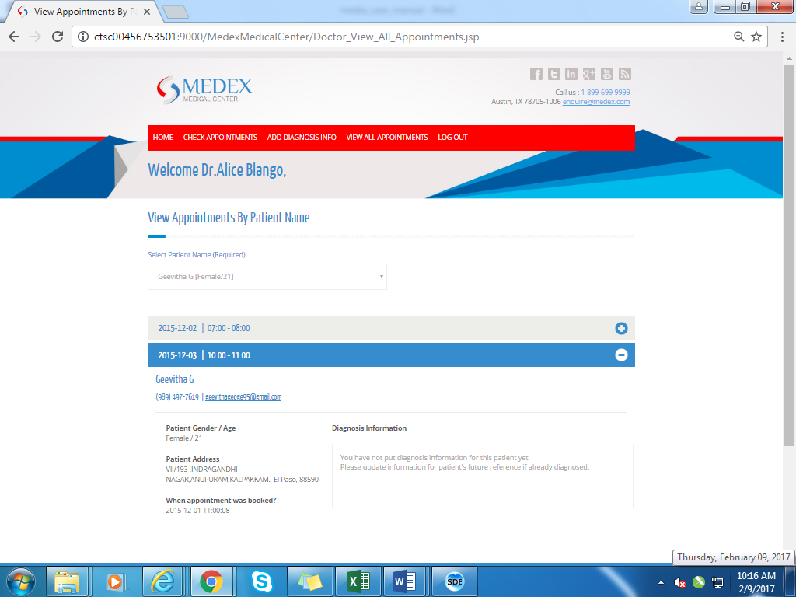

*Fig 12*